DETECTING AI GENERATED IMAGES WITH CNN AND INTERPRETATION USING EXPLAINABLE AI
Conclusion, Future Scope and References
Department of Computer Science and Engineering, [COLLEGE NAME]
Batch C14 (CSE-C) · Academic year [ACADEMIC YEAR]
Table 1: Project team
S.No. | Student name | Roll number
1 | Ponugoti Viduranandan | 23K91A05J5
2 | Naina Baherji | 23K91A05G9
3 | Likki Pranathi | 23K91A05D2
4 | Motasani Sathish | 23K91A05G0

Project guide: M Thanmayee
Chapter and section numbers quoted in the text (for example Chapter 8 or Section 6.2) refer to the full project report, 17.Final Document. Figures and tables in this document are numbered from 1.

1. CONCLUSION

1.1 Summary of the work
The project set out to detect AI-generated images with convolutional neural networks and to explain each decision with Grad-CAM. The result is VeriVision AI: four ImageNet-pretrained CNN routes (EfficientNet-B0 with two augmentation regimes, ResNet50 at 320 px and MobileNetV3-Large), fused in logit space with two deterministic gates, together with Grad-CAM heat maps, a per-image robustness check and a Flask and React application that runs entirely on the user's machine. The shipped models were first trained on synthetic demonstration images, whose perfect scores carry no meaning; they were replaced for this report by models trained on a real data subset, and every number in the report comes from those models.
On a class-balanced subset of the CIFAKE benchmark [8] (6,000 training, 1,200 validation and 2,000 held-out test images) the ensemble reached an accuracy of 92.35% (95% interval 91.1% to 93.5%), F1 0.9275 and ROC-AUC 0.9865. A single analysis through the API takes a median of 0.25 s for the verdict alone and 1.70 s with the heat maps and the robustness check, on a desktop CPU.

1.2 Objectives achieved
Table 2: Objectives of the project against the measured outcome
No. | Objective | Status | Evidence
1 | Assemble a dataset of real photographs and AI-generated images | Partly met | CIFAKE subset (one generator, 32 px) plus a 600-image full-resolution probe from another source; not several generators
2 | Preprocess and augment the images | Met | Per-route resizing, ImageNet normalisation and augmentation; the distortion-hardened route did not improve resize/blur robustness
3 | Train CNN classifiers | Met | Four routes; ensemble accuracy 92.35%, F1 0.9275, ROC-AUC 0.9865 on 2,000 held-out images
4 | Evaluate cross-generator performance | Measured, not achieved | Cross-domain probe: accuracy 51.0%, ROC-AUC 0.499 (chance level); generator and domain shift not separable
5 | Apply Grad-CAM | Met (qualitative) | Heat maps for three routes in every analysis; faithfulness not measured
6 | Deploy an interface with verdict, confidence and explanation | Met | Flask API + React app; /api/analyze median 1.70 s on CPU; 19/19 tests, 29/29 smoke checks

1.3 Key findings
1. The ensemble is the best model by ROC-AUC (0.9865), but its accuracy advantage over the best single route (A1, 91.80%) is not statistically distinguishable: the two bootstrap intervals overlap.
1. The fusion gates did not help. Gate 1 fired on 7 of 2,000 images and Gate 2 on 0; the ensemble without gates scored 92.45%. Logit-space fusion matched probability averaging on accuracy and beat it, and majority voting, on ROC-AUC.
1. Errors lean toward the AI-generated class (false-positive rate 13.1%, false-negative rate 2.2%). Wrong answers lie close to the decision boundary (mean fused margin 1.09 against 3.56 for correct answers), and all four routes agree on 81.2% of images.
1. Resizing and blurring remove the detectable cue on 32 px images: the ensemble falls to 61.0% and 58.3%, while JPEG q=60 and noise cost about four to five points. Distortion-hardened training did not change this.
1. The models do not transfer: on 600 full-resolution images from another source the ensemble scored 51.0% (ROC-AUC 0.499). Strong in-domain scores on CIFAKE therefore say little about modern generators.
1. Compared with the base paper [1] the only like-for-like figure is ROC-AUC: 98.65% here in-domain on CIFAKE against 98.9% on FaceForensics++ in the paper. The paper's DFDC figure (77.0%) and this project's cross-domain figure (49.9%) both fall when the data change, but the tasks, data and training regimes differ, so neither is evidence that one method is better.

1.4 Practical applications
As built, the tool suits teaching and demonstration: it shows how an ensemble, an explanation and a robustness check can be combined into one interface that runs offline. For an analyst it is a second opinion on small, compressed images similar to its training data, to be read together with the per-route votes, the heat map and the consistency score. It should not be used to decide a dispute on its own.

1.5 Known limitations
The limits that matter most are the small low-resolution single-generator training data, the chance-level cross-domain result, the fragility to resizing and blur, the bias toward the AI-generated class, the untuned gates and thresholds, the single training run per route, the qualitative explanations and the demonstration-grade sign-in. They are discussed in Chapters 1 and 8 and in the scope and limitations document, and the items that were not measured are listed there.
The results behind the key findings are shown below: the accuracy, F1 and ROC-AUC of each route and of the ensemble on the held-out test subset, and the fusion ablation that shows the two gates did not improve the result.
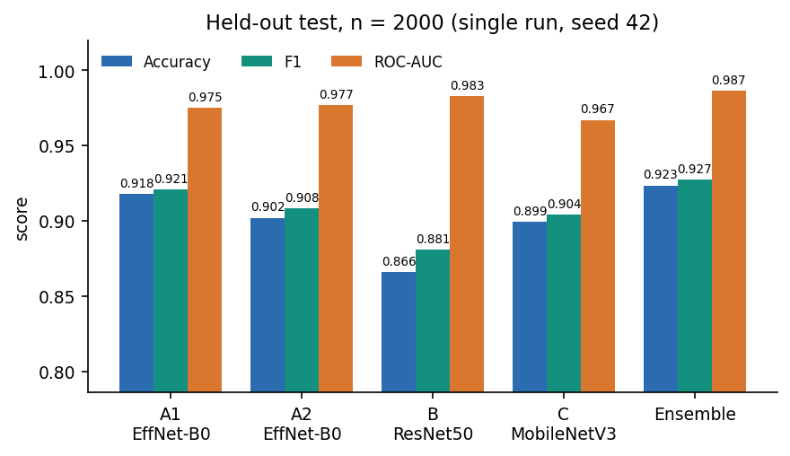
Figure 1: Accuracy, F1 and ROC-AUC of the four routes and the ensemble on the 2,000-image held-out test subset.
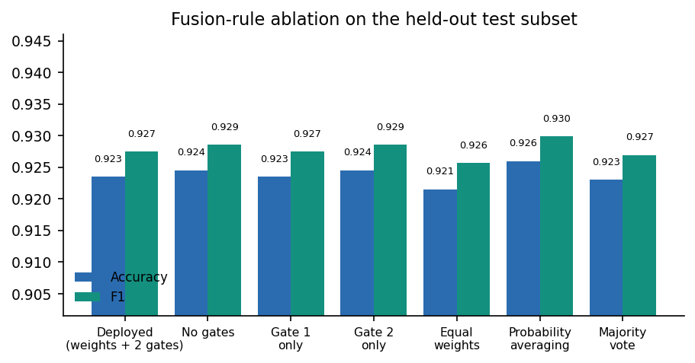
Figure 2: Fusion ablation on the same logits: weights only, gates, equal weights, probability averaging and majority vote.

2. FUTURE SCOPE

2.1 Improvements to the existing system
1. Train on the full data and on more generators. Use all 100,000 CIFAKE training images and add GAN and newer diffusion generators at several resolutions, then report accuracy per generator. This is the direct remedy for the chance-level cross-domain result (51.0%).
1. Tune the operating point on a validation set. Choose the decision threshold, the fusion weights and the gate thresholds on held-out validation data, not on the test set. The sweep suggests that a threshold of 0.7 would lower the false-positive rate from 13.1% to 7.2%; this must be confirmed on separate data.
1. Add features that survive resizing. Frequency-domain inputs [14] or frozen foundation-model features with a linear probe [13] transfer better across generators in the literature and could be added as a fifth route; whether they survive the half-size resample that defeated the CNNs here is an experiment to run.
1. Calibrate the probabilities. Apply temperature scaling per route and to the fused logits so that the confidence words (High, Moderate, Low) correspond to measured accuracy [25].
1. Run a seed study. Repeat training with five or more seeds, report mean and spread, and re-test whether the ensemble gain and the A2 result survive.

2.2 Additional features
• A per-generator or per-source breakdown on the Insights page once data from several generators exist.
• Batch upload and a downloadable report (verdict, votes, heat maps, robustness) for an analyst's case file.
• A saved-analysis history with per-user accounts and a database, with an explicit retention policy.
• Heat maps for route A2 and a switch between Grad-CAM variants, together with a short plain-language reading of each map.
• A "cannot decide" outcome when the routes disagree or when the image is far from the training resolution, instead of always returning a label.

2.3 Scalability and deployment
The analysis is CPU-bound and takes a median of 1.70 s with explanations. A deployment for several users would run the API behind a production WSGI server with a request queue, move the heat-map and robustness work to a background job, load models once per worker and cache results by image hash. A GPU would shorten training from hours to minutes and allow larger backbones and the full dataset. Before any shared deployment the demo account must be replaced with real authentication, the secret key must be set through the environment, and the demo credentials must no longer be returned by /api/config.

2.4 Further research
1. Quantitative faithfulness of the explanations. Test the Grad-CAM maps with deletion and insertion curves and with a small user study, and compare them with other attribution methods.
1. Separating generator shift from domain shift. Build a probe in which the real and fake images share content and resolution but differ in generator, so that the cause of the cross-domain failure can be identified.
1. Adversarial and post-processing robustness. Measure the detector under compression chains, screenshots, resizing pipelines and deliberate attacks designed to remove generation traces.
1. One-class and pseudo-fake training for general images. The base paper's one-class idea [1] was developed for faces; testing whether pseudo-fake training helps a general-image detector to generalise is an open question that this project did not address.

3. REFERENCES
[1] N. Larue, V. Struc, P. Peer and N.-S. Vu, "Learning the manifold of authenticity: hybrid-curvature representation learning for generalizable deepfake detection," IEEE Access, vol. 14, pp. 101988-102001, 2026, doi: 10.1109/ACCESS.2026.3702429.
[2] F. Wu, D. Lu, M. Yao, X. Xu and F. Guo, "HEDGE: Heterogeneous ensemble for detection of AI-generated images in the wild," arXiv:2604.03555, Apr. 2026.
[3] N. Tasnim, K. Uddin and K. M. Malik, "AI-generated image detection: an empirical study and future research directions," arXiv:2511.02791, Nov. 2025.
[4] "Deepfake and AI-generated image detection system," Int. J. Multidisciplinary Research (IJFMR), 2025. [unverified: listed as recorded in the batch survey; authors, volume and pages not confirmed]
[5] "Deepfake tweet detection using CNN and FastText embeddings: leveraging deep learning to identify AI-generated tweets," 2025. [unverified: listed as recorded in the batch survey; text-based study, authors and venue not confirmed]
[6] "Multimodal deepfake detection across cultures and languages," in Proc. 1st Deepfake Forensics Workshop: Detection, Attribution, Recognition, and Adversarial Challenges in the Era of AI-Generated Media, 2025. [unverified: listed as recorded in the batch survey; authors and pages not confirmed]
[7] "Deepfake detection using deep learning: a neural network-based approach to identifying AI-generated media," 2025. [unverified: listed as recorded in the batch survey; authors and venue not confirmed]
[8] J. J. Bird and A. Lotfi, "CIFAKE: image classification and explainable identification of AI-generated synthetic images," IEEE Access, vol. 12, pp. 15642-15650, 2024 (arXiv:2303.14126).
[9] A. Krizhevsky, "Learning multiple layers of features from tiny images," Univ. Toronto, Toronto, ON, Canada, Tech. Rep., 2009.
[10] R. Rombach, A. Blattmann, D. Lorenz, P. Esser and B. Ommer, "High-resolution image synthesis with latent diffusion models," in Proc. IEEE/CVF Conf. Comput. Vis. Pattern Recognit. (CVPR), 2022, pp. 10684-10695.
[11] I. Goodfellow et al., "Generative adversarial nets," in Proc. Adv. Neural Inf. Process. Syst. (NeurIPS), vol. 27, 2014, pp. 2672-2680.
[12] S.-Y. Wang, O. Wang, R. Zhang, A. Owens and A. A. Efros, "CNN-generated images are surprisingly easy to spot... for now," in Proc. IEEE/CVF CVPR, 2020, pp. 8695-8704.
[13] U. Ojha, Y. Li and Y. J. Lee, "Towards universal fake image detectors that generalize across generative models," in Proc. IEEE/CVF CVPR, 2023, pp. 24480-24489.
[14] J. Frank, T. Eisenhofer, L. Schonherr, A. Fischer, D. Kolossa and T. Holz, "Leveraging frequency analysis for deep fake image recognition," in Proc. 37th Int. Conf. Mach. Learn. (ICML), PMLR vol. 119, 2020, pp. 3247-3258.
[15] R. Corvi, D. Cozzolino, G. Zingarini, G. Poggi, K. Nagano and L. Verdoliva, "On the detection of synthetic images generated by diffusion models," in Proc. IEEE Int. Conf. Acoust., Speech Signal Process. (ICASSP), 2023, pp. 1-5.
[16] D. Gragnaniello, D. Cozzolino, F. Marra, G. Poggi and L. Verdoliva, "Are GAN generated images easy to detect? A critical analysis of the state-of-the-art," in Proc. IEEE Int. Conf. Multimedia Expo (ICME), 2021, pp. 1-6.
[17] A. Rossler, D. Cozzolino, L. Verdoliva, C. Riess, J. Thies and M. Niessner, "FaceForensics++: learning to detect manipulated facial images," in Proc. IEEE/CVF Int. Conf. Comput. Vis. (ICCV), 2019, pp. 1-11.
[18] Y. Li, X. Yang, P. Sun, H. Qi and S. Lyu, "Celeb-DF: a large-scale challenging dataset for DeepFake forensics," in Proc. IEEE/CVF CVPR, 2020, pp. 3207-3216.
[19] M. Tan and Q. Le, "EfficientNet: rethinking model scaling for convolutional neural networks," in Proc. 36th Int. Conf. Mach. Learn. (ICML), PMLR vol. 97, 2019, pp. 6105-6114.
[20] K. He, X. Zhang, S. Ren and J. Sun, "Deep residual learning for image recognition," in Proc. IEEE Conf. Comput. Vis. Pattern Recognit. (CVPR), 2016, pp. 770-778.
[21] A. Howard et al., "Searching for MobileNetV3," in Proc. IEEE/CVF ICCV, 2019, pp. 1314-1324.
[22] T.-Y. Lin, P. Goyal, R. Girshick, K. He and P. Dollar, "Focal loss for dense object detection," in Proc. IEEE ICCV, 2017, pp. 2980-2988.
[23] I. Loshchilov and F. Hutter, "Decoupled weight decay regularization," in Proc. Int. Conf. Learn. Represent. (ICLR), 2019.
[24] J. Deng, W. Dong, R. Socher, L.-J. Li, K. Li and L. Fei-Fei, "ImageNet: a large-scale hierarchical image database," in Proc. IEEE CVPR, 2009, pp. 248-255.
[25] C. Guo, G. Pleiss, Y. Sun and K. Q. Weinberger, "On calibration of modern neural networks," in Proc. 34th Int. Conf. Mach. Learn. (ICML), PMLR vol. 70, 2017, pp. 1321-1330.
[26] R. R. Selvaraju, M. Cogswell, A. Das, R. Vedantam, D. Parikh and D. Batra, "Grad-CAM: visual explanations from deep networks via gradient-based localization," in Proc. IEEE ICCV, 2017, pp. 618-626.
[27] J. Gildenblat and contributors, "PyTorch library for CAM methods (pytorch-grad-cam)," GitHub repository, 2021. [Online]. Available: https://github.com/jacobgil/pytorch-grad-cam
[28] A. Paszke et al., "PyTorch: an imperative style, high-performance deep learning library," in Proc. Adv. Neural Inf. Process. Syst. (NeurIPS), vol. 32, 2019, pp. 8024-8035.
[29] F. Pedregosa et al., "Scikit-learn: machine learning in Python," J. Mach. Learn. Res., vol. 12, pp. 2825-2830, 2011.
[30] Pallets Projects, "Flask documentation," 2024. [Online]. Available: https://flask.palletsprojects.com/
[31] B. Efron and R. J. Tibshirani, An Introduction to the Bootstrap. New York, NY, USA: Chapman & Hall, 1993.

